Author Highlight
Melanie Moyer and Kathe Hudson
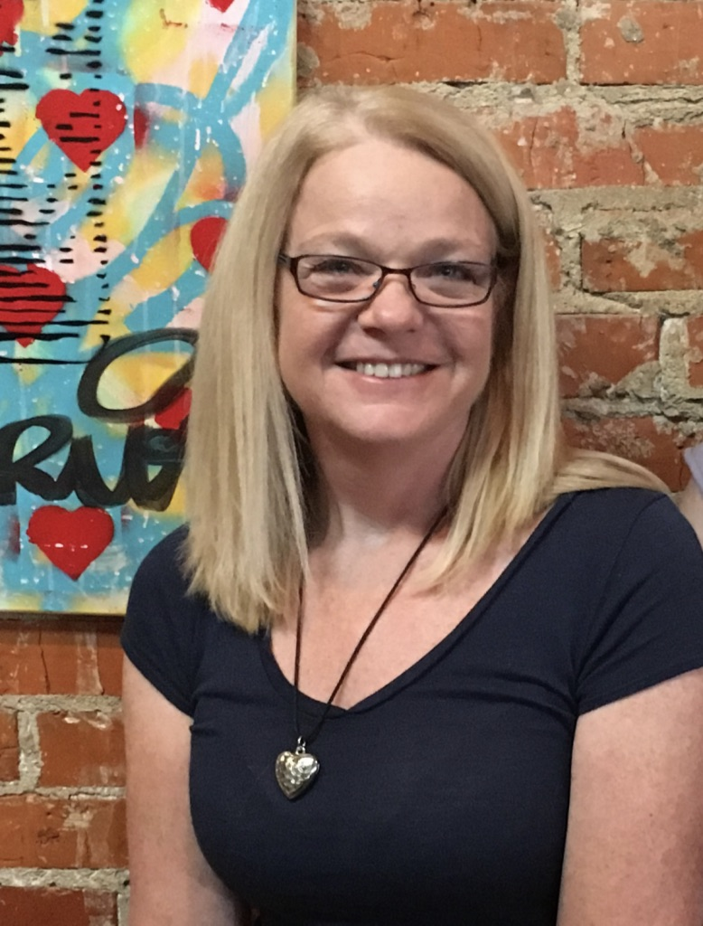
Melanie and Kathe are former librarians; yogis and children’s book authors passionate about promoting literacy, health and well-being.

We stretch bodies and minds through timeless wisdom tales told with a yogic twist. These stories instill enduring virtues such as kindness, honesty, compassion, friendship, moderation, generosity, gratitude, contentment, faith, and joy.

Our series, A Yoga Storytelling Adventure, introduces kids to yoga offering a unique interactive experience that enhances their curiosity about the world while encouraging their innate creativity and engaging them in mindful movement.
Each book includes a full description of yoga poses encouraging kids to make the story come alive!
Melanie

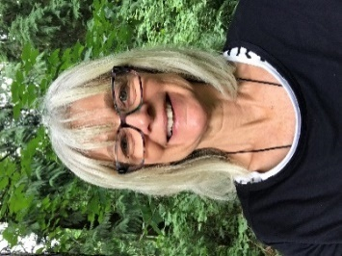
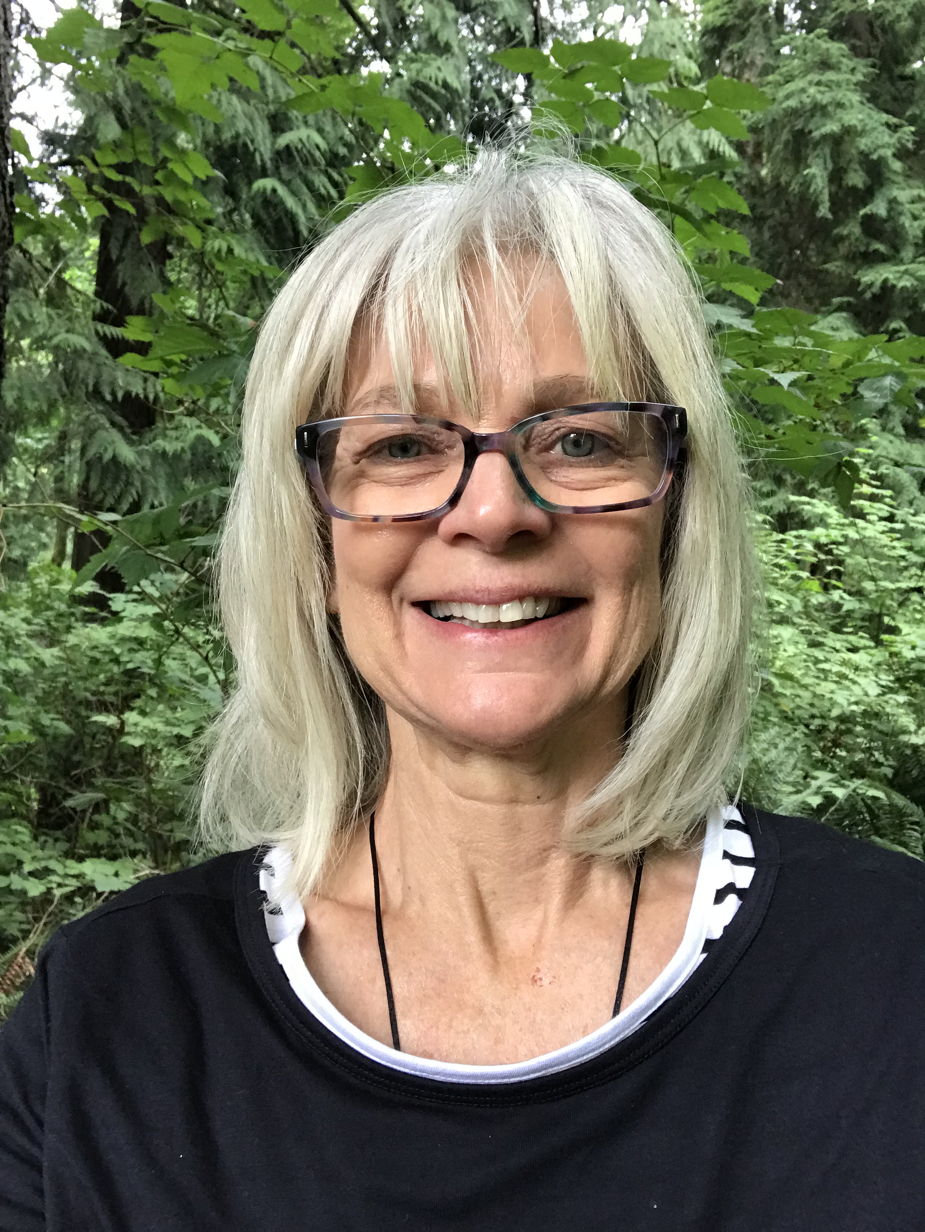

Interview with the authors Kathe

Q. Where did you get the inspiration for your series?
As yogis and children’s programming librarians, we created a unique program that introduced children to yoga through story. Kids loved it! The inspiration for our books came from parents and teachers who encouraged us to share this experience with others.
Q. Why did you choose wisdom tales?
We chose wisdom tales as they are the world’s oldest form of literature. These traditional tales have survived for hundreds of years and have power to speak to the lives of children today.
Q. How do you hope these books will make an impact on the children that read them?
We hope our books inspire children to express themselves through story and yoga. Story enhances language, listening and critical thinking skills. Yoga enhances body and mind awareness. These twin arts bring balance, strength, and flexibility to body and mind creating calm, confident, compassionate kids.

Through the magic of story and the wisdom of yoga let the adventure begin!
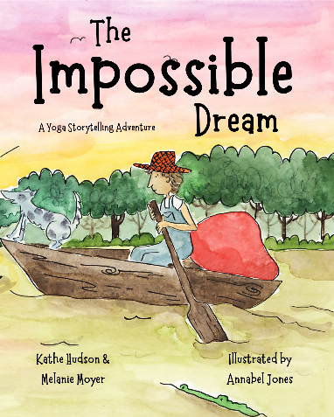
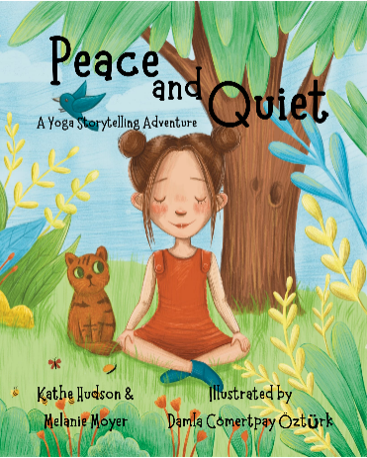
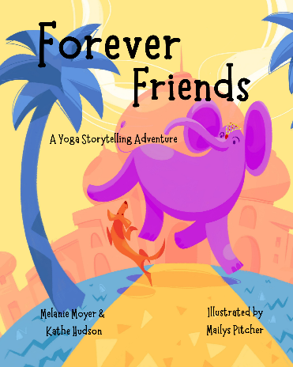
This Yoga Storytelling Adventure takes us on a delightful journey to India, the birthplace of yoga, where an unlikely friendship develops between a royal elephant and a homeless dog.
In this timeless tale that illuminates kindness, honesty and friendship, kids will learn about the power of love.
Included is a Hindi word guide to help develop an appreciation of a different language, and best of all, a full description of yoga poses makes the story come alive as you go on A Yoga Storytelling Adventure!

This Yoga Storytelling Adventure takes us deep in the swamplands where a young man embarks on an extraordinary adventure. Night after night he has the same strange dream until he can no longer ignore it. Find out what he discovers on his daring journey.
Contentment, determination, and the power of believing in oneself expound in this timeless tale.

Included is a Cajun word guide to help develop an appreciation of a different language, and best of all, a full description of yoga poses makes the story come alive as you go on A Yoga Storytelling Adventure!

This Yoga Storytelling Adventure takes us on a whimsical journey to Eastern Europe, where a mild-mannered girl thinks she lives in a noisy and chaotic house until her wise neighbor turns her world upside down and she sees things in a different way.
In this timeless tale kids learn that they may not be able to control the world around them; however, they can control their inner world. Kids will discover a simple way to stay calm, focused and alert with three easy breathing exercises to use as a means of self-empowerment.
Included is a Polish word guide to help develop an appreciation of a different language, and best of all, a full description of yoga poses makes the story come alive as you go on A Yoga Storytelling Adventure!

Visit us at www.ayogastorytellingadventure.com

We love hearing from you! Contact us at movingtale@gmail.com

